Instagram User Analytics
SQL Fundamentals

Project Description
- This project aims to extract useful insights from raw data/metadata. Using various database management tools and even visualise them to increase the platform’s efficiency.

Project Approach
- The project was executed using SQL where queries were utilized to create a database from the provided raw data. Sorting and data extracting queries were then implemented to obtain the required data/insights.

Tech Stack Used
- The Tech stack used included MySQL Workbench v8.0.30.0 which was an excellent tool for querying the database, thanks to its ease of access, simple setup and GUI as well as its troubleshooting support.

Project Insights:
A) Marketing:
- 1.) Rewarding most loyal users: People who have been using the platform for the longest time.
- CODE:-
- select * from users order by created_at limit 5;
- RESULT:-
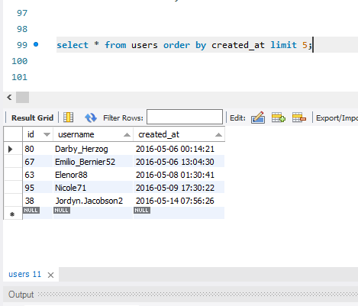
2.) Remind inactive users to start posting: By sending them promotional emails to post their photos.
CODE:’-
- select username from users left join photoson users.id=photos.user_idwhere photos.id is null
RESULT:-
# USERNAME
- Aniya_Hackett
- Kasandra_Homenick
- Jaclyn81, Rocio33
- Maxwell.Halvorson
- Tierra.Trantow
- Pearl7
- Ollie_Ledner37
- Mckenna17
- David.Osinski47
- Morgan.Kassulke
- Linnea59, Duane60
- Julien_Schmidt
- Mike.Auer39
- Franco_Keebler64
- Nia_Haag
- Hulda.Macejkovic
- Leslie67
- Janelle.Niklaus81
- Darby_Herzog
- Esther.Zulauf61
- Bartholome.Bernhard
- Jessyca_West
- Esmeralda.Mraz57
- Bethany20.
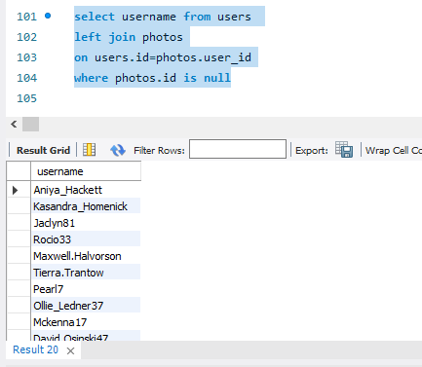

3.) Contest Winner Declaration: The team has organized a contest where the user with the most likes on a single photo wins.
Code:- select username , photos.id , photos.image_url , count(likes.user_id) as total_likes from photos
inner join likes on likes.photo_id=photos.id
inner join users on photos.user_id=users.id
group by photos.id order by total_likes desc limit 1;
- Result:-

username | id | Photo_url | Total_likes

Zack_Kemmer93 | 145 | https://jarret.name | 48

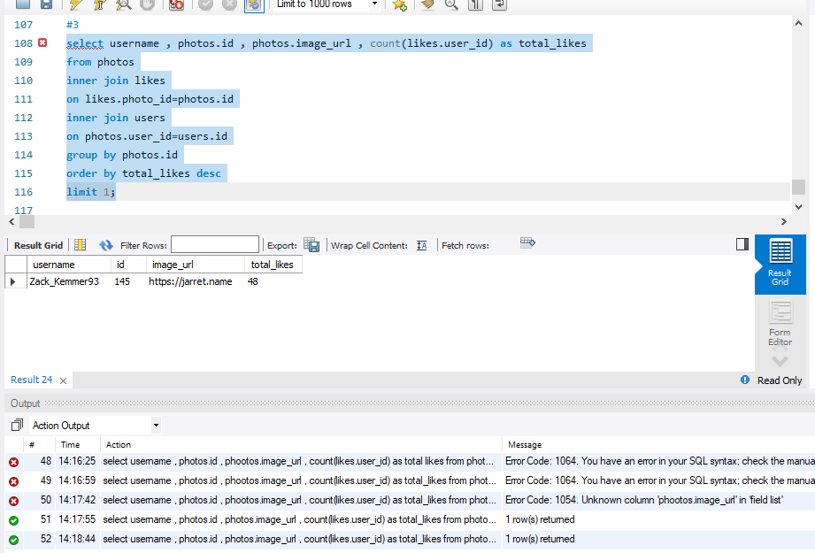

4.) Hashtag Research: A partner brand wants to know the most popular hashtags to use in their posts to reach the most people.
- CODE:-

select tag_name , count(*) as total
from tags
join photo_tags
on photo_tags.tag_id=tags.id
group by tag_id
order by total desc
limit 5;

RESULT:-

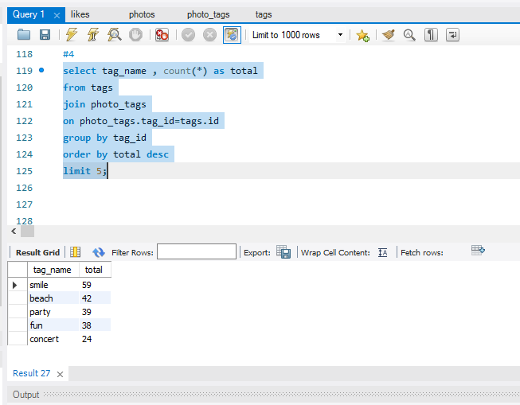
5). Ad Campaign Launch: The team wants to know the best day of the week to launch ads.

CODE:-
select dayname(created_at) as days , count(*) as total
from users
group by days
order by total desc
limit 3;

RESULT:-
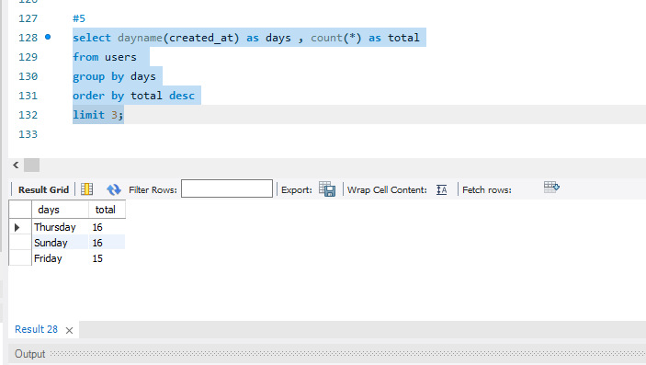
B) Investor Metrics:
- User Engagement: Investors want to know if users are still active and posting on Instagram or if they are making fewer posts.
CODE:-
Select
(select count(*) from photos) / (select count(*) from users) as avg

RESULT:-
257.00

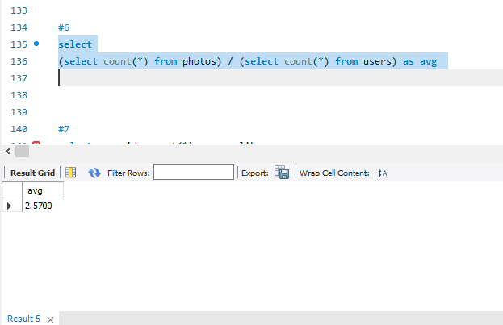

2). Bots & Fake Accounts: Investors want to know if the platform is crowded with fake and dummy accounts.
CODE:-
select user_id, count(*) as num_likes
from likes
group by user_id
having num_likes = (select count(*) from photos);
select u.username, count(*) as num_likes
from users u
join likes l on u.id = l.user_id
group by u.id
having num_likes = (select count(*) from photos);

RESULT:-
username | num_likes

Aniya_Hackett | 257
Jaclyn81 | 257
Rocio33 | 257
Maxwell.Halvorson | 257
Ollie_Ledner37 | 257
Mckenna17 | 257
Duane60 | 257
Julien_Schmidt | 257
Mike.Auer39 | 257
Nia_Haag | 257
Leslie67 | 257
Janelle.Nikolaus81 | 257
Bethany20 | 257

